A1308-Asia Indus Valley-Idol figure-Terracotta-900-800 BCE.

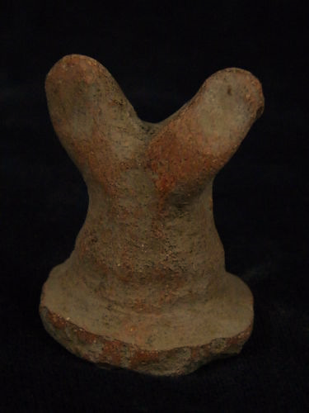 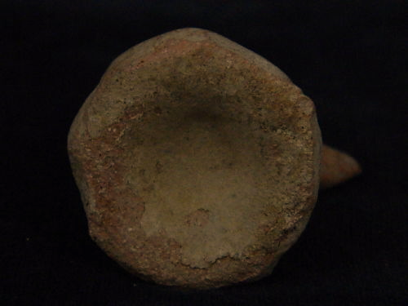

**Accession Number:** A1307

**Case no.:** 3

**Formal Label:** Indus Valley-Figurine-Abstract Horned Animal figurine-2800 BCE-2600 BCE

**Display Description:**

This abstract animal terracotta figurine, has horns that extend from head. It has been cast with a cylindrical body with an everted, molded base. Its function can only have been ritualistic. Being made of terracotta, it has originated with the Earth but its horns point to the heavens. An archetypal abstract horned individual emerges with the Iron Age, ca 600 CE to be projected as a local male divinity of animals connected with Indio-European myths.

**Cultural Affiliation:** Indus

**Medium**: terracotta

**Dimensions:** H 5 cm  3.5 cm Length  
**Weight:**

**Condition:** original

**Provenance:** part of an old European collection

**Discussion:**

Horned male deities and shamans are associated with many Celtic myths and images.

**References:**

Mallory, J. P. 1997. *Encyclopedia of Indo-European culture*. London; Chicago: Fitzroy Dearborn.